**Background**

R dogma is that for loops are bad because they are slow but this is not the case in C++. I had never programmed a line of C++ as of last week but my beloved firstborn started university last week and is enrolled in a C++ intro course, so I thought I would try to learn some and see if it would speed up Passing Bablok regression.

**Passing Bablok Regression**

As mentioned in the past, the field of Clinical Chemistry has a peculiar devotion to Passing Bablok regression… and hey, why not?

Here is the code for a minimal implementation of Passing Bablok regression as discussed in [this paper](https://www.degruyter.com/view/j/cclm.1988.26.issue-11/cclm.1988.26.11.783/cclm.1988.26.11.783.xml). This is the scale-invariant version.

PB.reg <- function(x,y){

lx <- length(x)

l <- lx*(lx - 1)/2

k <- 0

S <- rep(NA, lx)

for (i in 1:(lx - 1)) {

for (j in (i + 1):lx) {

k <- k + 1

S[k] <- (y[i] - y[j])/(x[i] - x[j])

}

}

S.sort <- sort(S)

N <- length(S.sort)

neg <- length(subset(S.sort,S.sort < 0))

K <- floor(neg/2)

if (N %% 2 == 1) {

b <- S.sort[(N+1)/2+K]

} else {

b <- sqrt(S.sort[N / 2 + K]*S.sort[N / 2 + K + 1])

}

a <- median(y - b * x)

return(as.vector(c(a,b)))

}

So let’s make some fake data and see what we get:

set.seed(314)

x <- seq(1, 100, length.out = 100)

y <- 1.1* x + 20 + x*rnorm(100,0,0.10)

reg <- PB.reg(x,y)

round(reg,2)

## [1] 18.90 1.14

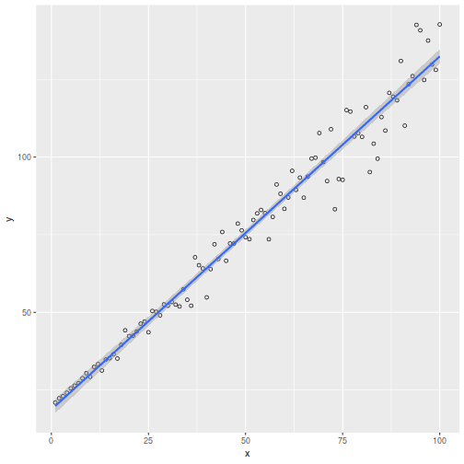

Just to sanity check, we can get the coefficients from the mcr() package.

library(mcr)

reg.mcr <- mcreg(x,y)

round(reg.mcr@glob.coef,2)

## [1] 18.90 1.14

Ok, looks good.

**Rcpp**

The [Rcpp](https://cran.r-project.org/web/packages/Rcpp/index.html) package permits compiling and execution of C++ code from within R. This can be good for computationally intensive tasks. Here is my child-like attempt at recapitulation of the R script above.

#include

#include

#include

#include

#include

#include

#include "Rcpp.h"

using namespace std;

using namespace Rcpp;

// [[Rcpp::plugins("cpp11")]]

// [[Rcpp::export]]

vector PB(vector x,vector y){

int lx=x.size();

int l=lx*(lx-1)/2;

int k=-1;

vector S(l,numeric_limits::quiet_NaN());

vector sortS;

vector neg;

double b;

double a;

vector aVec(x.size());

vector coef(2);

// Calculate the components of the S Matrix

for(int i=0; i :: iterator it = S.begin(); it != S.end(); ++it){

if (!isnan(*it)) sortS.push_back((*it));

}

// Put all the negative values into a vector called neg

for(vector :: iterator it = S.begin(); it != S.end(); ++it){

if ((*it)<0) neg.push_back((*it));

}

// Calculate N and K

int K=int(floor(float(neg.size()/2)));

int N=sortS.size();

// Calculate the slope

if (N%2==1) {

b=S[static_cast ((N+1)/2+K-1)];

} else {

b=sqrt(S[static_cast (N/2+K-1)]*S[static_cast (N/2+K)]);

}

// Make a vector aVec of the estimates of the intercept

for(int i=0; i((x.size()+1.0)/2.0-1.0)];

}else{

a=(aVec[static_cast (x.size()/2.0-1.0)] + aVec[static_cast (x.size()/2.0)])/2.0;

}

// Report results

coef[0]=a;

coef[1]=b;

return coef;

}

int main(){

return 0;

}

Saving this to a local directory as PB_Reg.cpp, we can compile it and call the function into the R session as follows:

library(Rcpp)

sourceCpp("PB_Reg.cpp")

And run it:

round(PB(x,y),2)

## [1] 18.90 1.14

Looks good! But is it faster? Like really faster? Let’s find out. And let’s also compare it to what the compiler() package produces:

library(compiler)

PB.reg.cmpfun <- cmpfun(PB.reg)

library(rbenchmark)

bmark <- benchmark(

Rscript = PB.reg(x,y),

`Compiler Package` = PB.reg.cmpfun(x,y),

Rcpp = PB(x,y),

replications = 100,

order = "relative"

)

knitr::kable(bmark)

|  | **test** | **replications** | **elapsed** | **relative** | **user.self** | **sys.self** | **user.child** | **sys.child** |
| --- | --- | --- | --- | --- | --- | --- | --- | --- |
| 3 | Rcpp | 100 | 0.024 | 1.000 | 0.024 | 0.000 | 0 | 0 |
| 2 | Compiler Package | 100 | 0.214 | 8.917 | 0.214 | 0.000 | 0 | 0 |
| 1 | Rscript | 100 | 0.217 | 9.042 | 0.213 | 0.004 | 0 | 0 |

So this makes C++ code about 9x faster than R source code. Not bad but in this case it was probably not worth the effort. Oh well. I learned something. Incidentally, the compiler() package did not help much in this case as it is only marginally better than raw R source. I have seen better results from compiler() in other cases.

**Final thought**

Speaking of speed:

*“Free yourself, like a gazelle from the hand of the hunter, like a bird from the snare of the fowler.”*